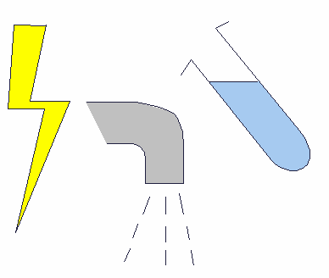
Name: Date:

Electrical circuit

- Make a working electrical circuit with:
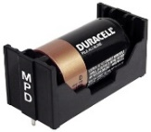
One cell
Lamp

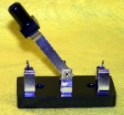
Switch

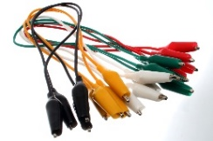
Wires

- Draw and Label the circuit diagram built using ruler and pencil

- State what happened when the switch is closed
__________________________________________________

