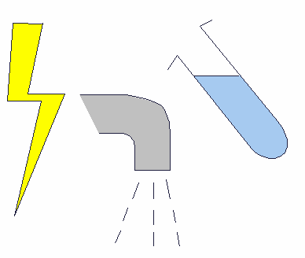 **Name: Date:**

**Electrical circuit**

1. Make a working electrical circuit with:

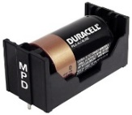

Cell



Lamp

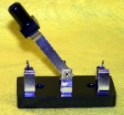

Switch

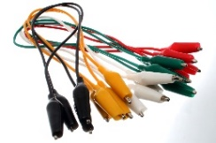

Wires

1. Picture of circuit built: Label the components used.
2. State what happened when the switch is closed.

______________________________________________

______________________________________________