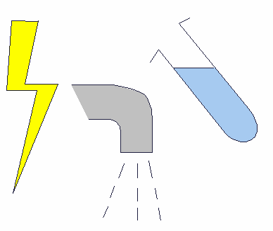
Name: Date:

Electrical circuit

- Make a working electrical circuit with:
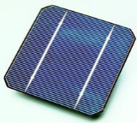
Solar cell

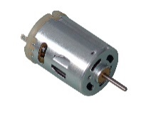
Motor

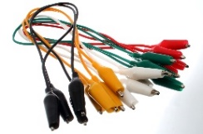
Wires

- Picture of circuit built: Label the components.

- What happened to the motor when the solar cell was directed towards the sunlight?
______________________________________________
______________________________________________

