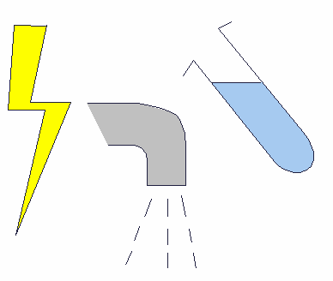
Name: Date:

Electrical circuit

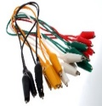
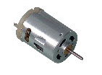
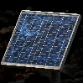
- Make a working electrical circuit with: a solar cell (photovoltaic cell), motor and some wires.

- Draw and label the circuit diagram using pencil and ruler. Keep your circuit diagram inside of the box below:

- Write down what happened when the light is shone on the solar cell.
______________________________________________
______________________________________________
______________________________________________

