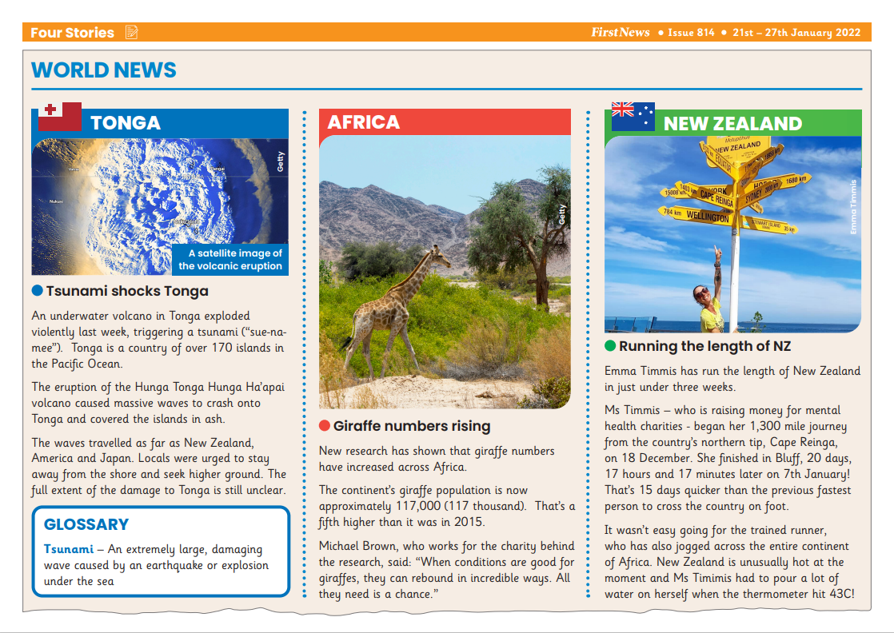
814
World News

What triggered the tsunami?
An underwater ……………………….. triggered the tsunami.

Where is the Tonga?
The Tonga is in the ……………………… Ocean.

Where were locals urged to go?
The locals were urged to go to ……………………………………………………...

What has happened to the number of giraffes across Africa?
The number of giraffes have …………………………………….. across Africa.

What is the approximate number of giraffes in Africa?
The approximate number of giraffes is …………….. thousand.

What is the name of the man who works for the charity behind the research?
The man’s name is ………………………………………………………….

How long did it take Emma Timmis to run the length of New Zealand?
It took Emma just under ………………………………………………. to run the length of New Zealand.

How many miles was Emma’s run?
Emma’s run was ……………………………………… miles

How hot did it get on Emma’s run?
The temperature got to ……………………………. on Emma’s run.

814
World News

An underwater volcano triggered the tsunami.
The Tonga is in the Pacific Ocean.
The locals were urged to go to higher ground.
The number of giraffes have increased across Africa.
The approximate number of giraffes is 117 thousand.
The man’s name is Michael Brown.
It took Emma just under three weeks to run the length of New Zealand.
Emma’s run was 1,300 miles
The temperature got to 43˚c on Emma’s run.

814
World News

What triggered the tsunami?
An underwater volcano a big storm a hurricane

Where is the Tonga?
Atlantic Ocean Artic Ocean Pacific Ocean.

Where were locals urged to go?
the forests higher ground the beach

What has happened to the number of giraffes across Africa?
decreased stayed the same increased

What is the approximate number of giraffes in Africa?
117 thousand 121 thousand 2015 thousand

What is the name of the man who works for the charity behind the research?
Michael Blue Michael Black Michael Brown

How long did it take Emma Timmis to run the length of New Zealand?
just under three weeks just over three weeks three weeks

How many miles was Emma’s run?
3,100 miles 1,300 miles 130 miles

How hot did it get on Emma’s run?
34˚c 43˚c 83˚c

814
World News

What triggered the tsunami?

Where is the Tonga?

Where were locals urged to go?

What has happened to the number of giraffes across Africa?

What is the approximate number of giraffes in Africa?

What is the name of the man who works for the charity behind the research?

How long did it take Emma Timmis to run the length of New Zealand?

How many miles was Emma’s run?

How hot did it get on Emma’s run?

814
World News

What triggered the tsunami?

Where is the Tonga?

Can you name a book or story that features a tsunami?

What has happened to the number of giraffes across Africa?

What is the approximate number of giraffes in Africa?

What is the name of the man who works for the charity behind the research?

How long did it take Emma Timmis to run the length of New Zealand?

How many miles was Emma’s run?

Why do you think Emma decided to do this run?

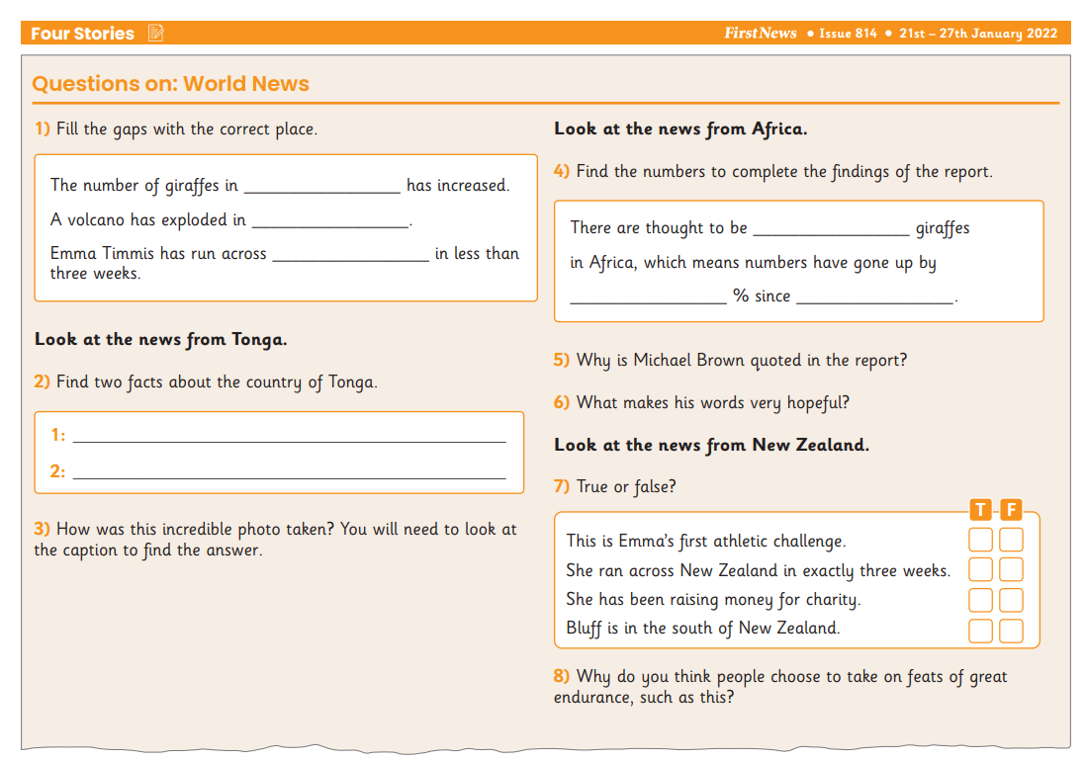
How many words can you make from..

New Zealand runner

